NACD Stewardship Week 2025 – Sample Social Media Captions
Please use these as suggested posts and captions. Feel free to change them up to make them most relevant for your area and post in any order throughout the week!
Find all graphics here: https://nacdnet.app.neoncrm.com/np/viewDocument?orgId=nacdnet&id=40288a55963815bd01963a7c93f70015
Want to make a post with unique habitat facts for your district? Check out the free template here on canva! Just click the “Use template for new design” button.

Post | Caption
HASHTAGS TO USE ACROSS POSTS | #NACDStewardshipWeek #HomeIsWhereTheHabitatIs  #habitats #wildlife #conservation #NACD #SWCD #conservationdistricts #conservationeducation
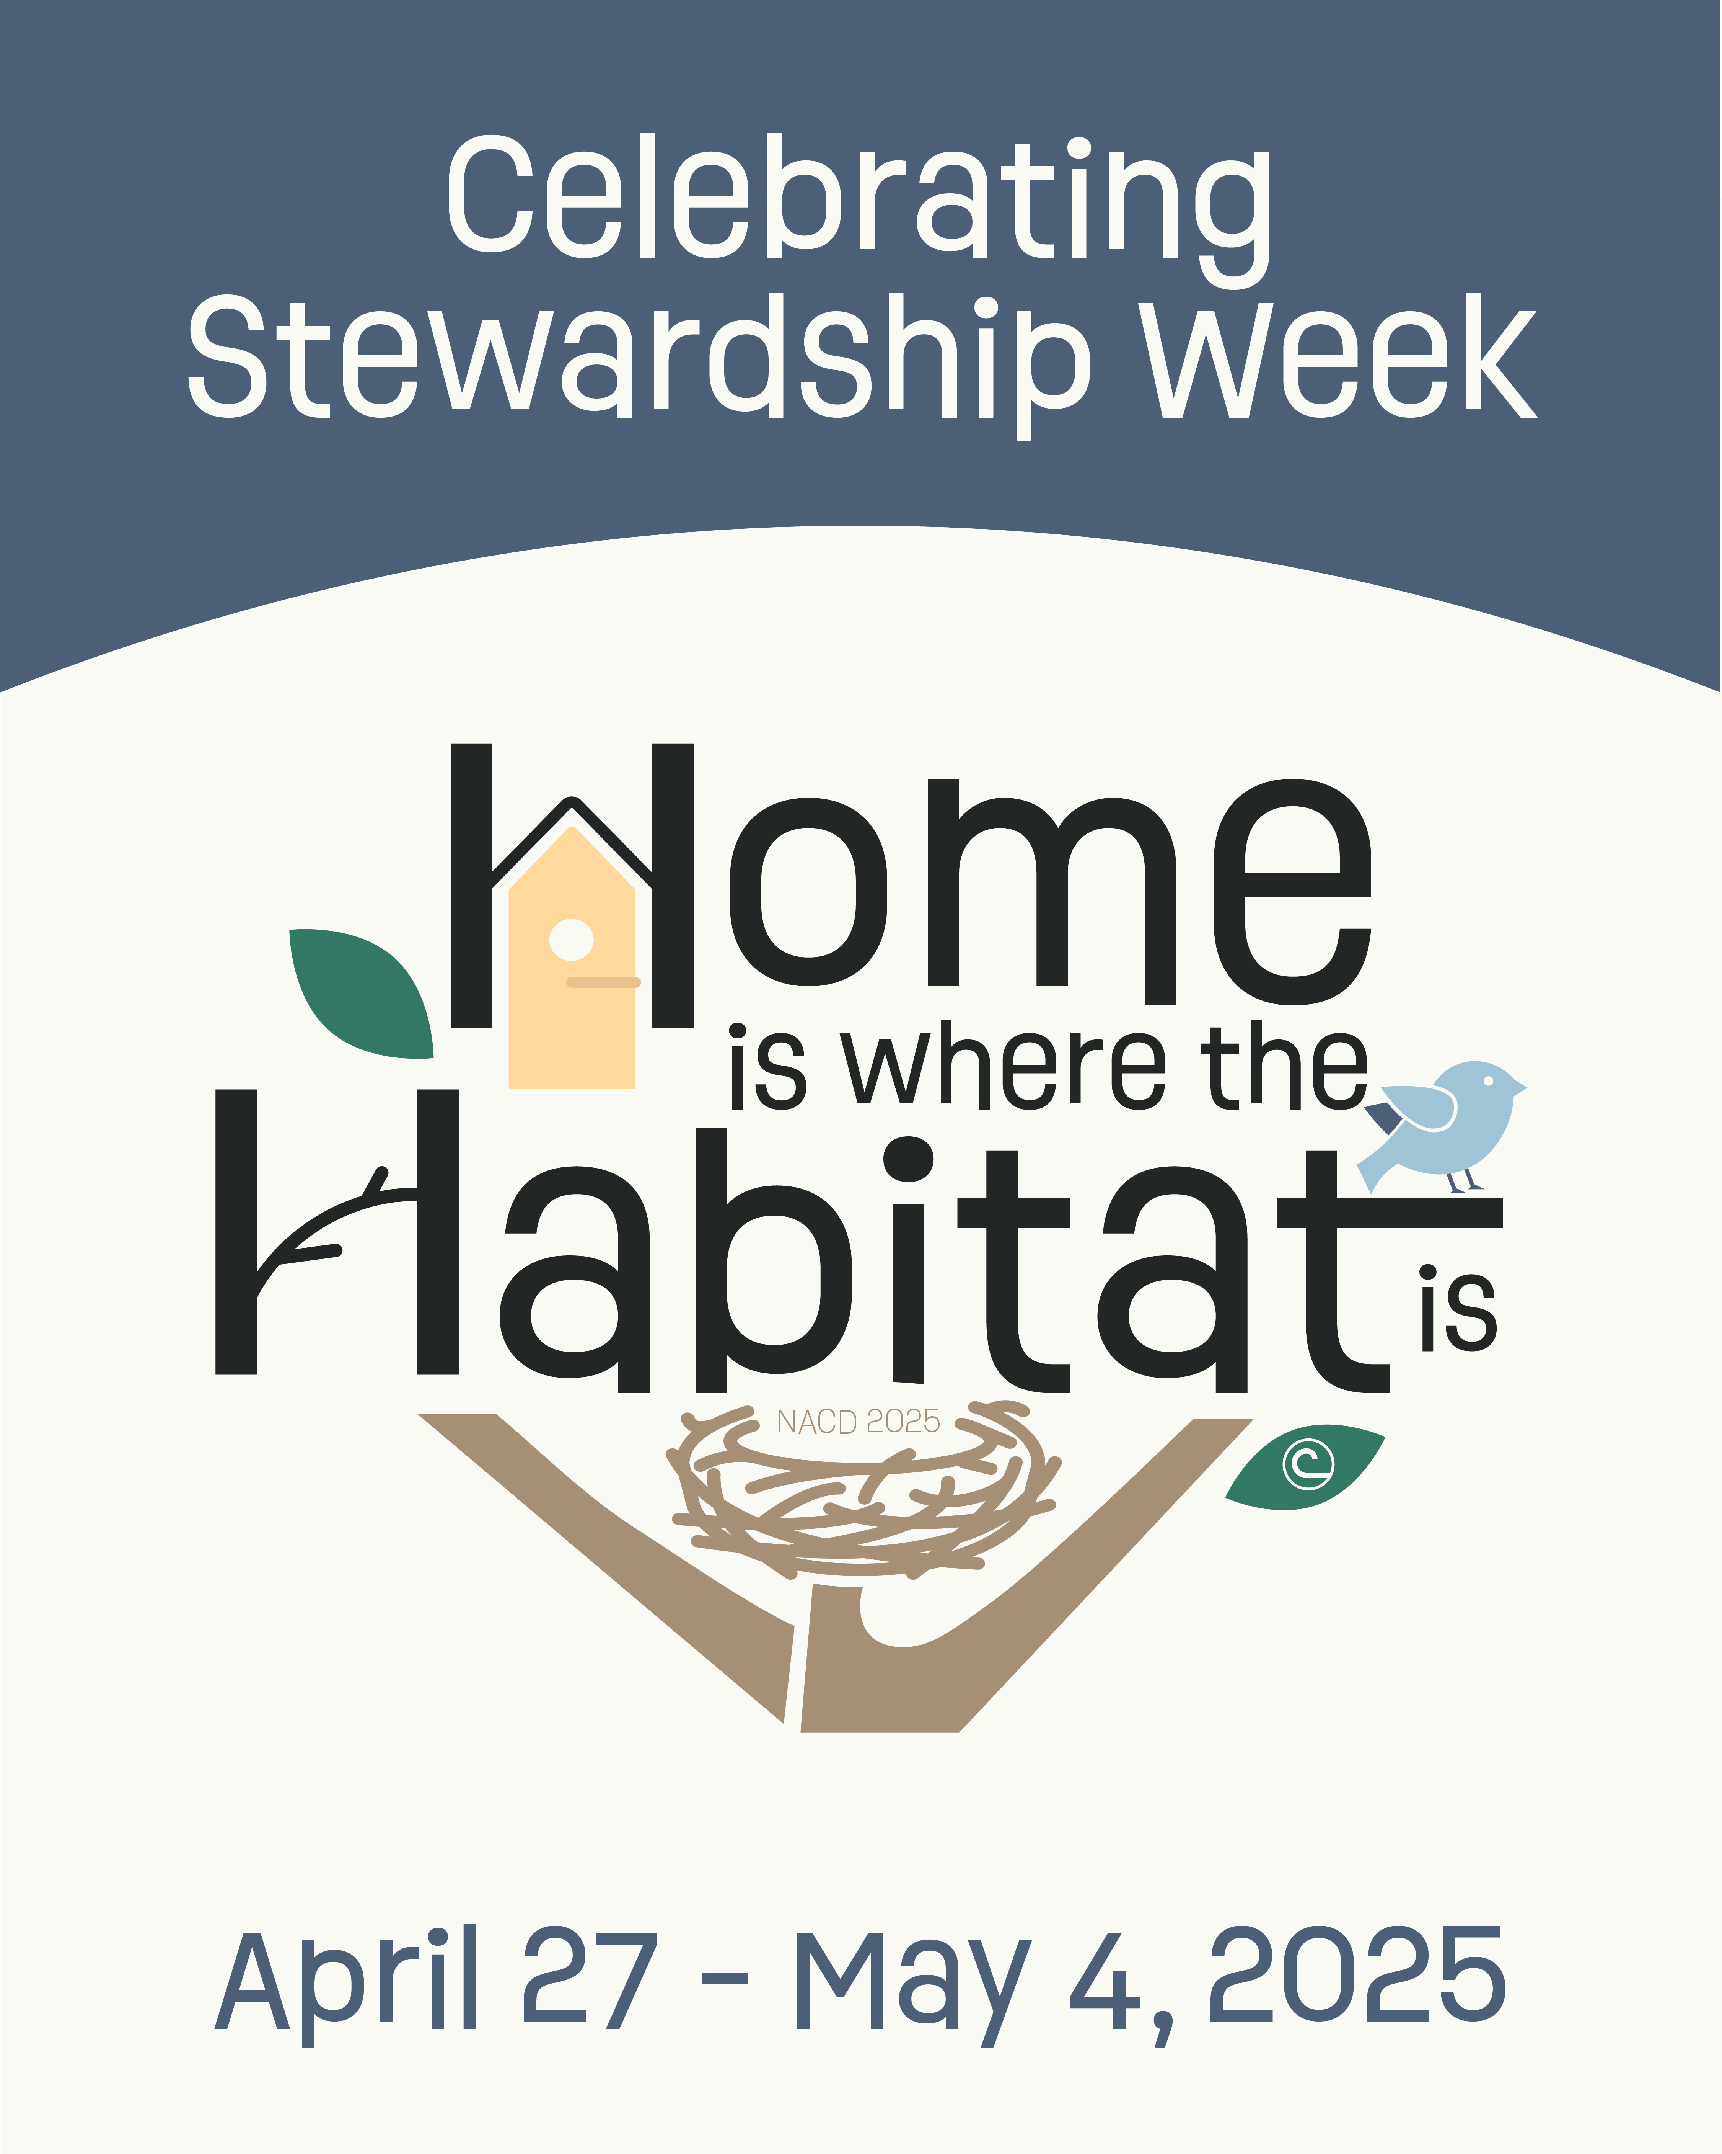 | Celebrate #NACDStewardshipWeek with us! This week, we are talking about the importance of #habitats. Follow along with us to learn about habitats and their inhabitants and how you can help keep your local plants and wildlife protected. #HomeIsWhereTheHabitatIs  Visit @nacdconserve at bit.ly/nacd-sw25 to get involved! Here you’ll find educational materials, habitat conservation projects, and social media initiatives that you can use throughout the week. [Promote ways to get involved with your district here too!]
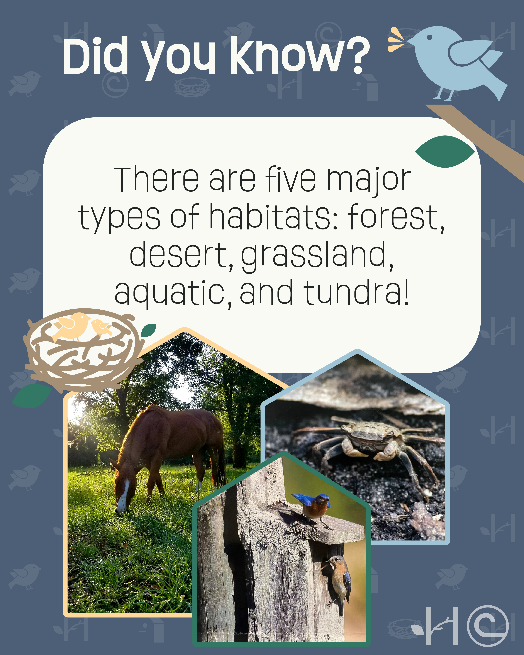 | FIVE TYPES OF HABITATS  Habitats come in all shapes and sizes! However, they can all be categorized into one of five major types: forest, desert, grassland, aquatic, or tundra! 🌳🌵🦗🌊🐧  [Mention the habitats in your area/state.] (i.e. Here in California, we have forest, grassland, desert, and aquatic habitats!).  #NACDStewardshipWeek #HomeIsWhereTheHabitatIs
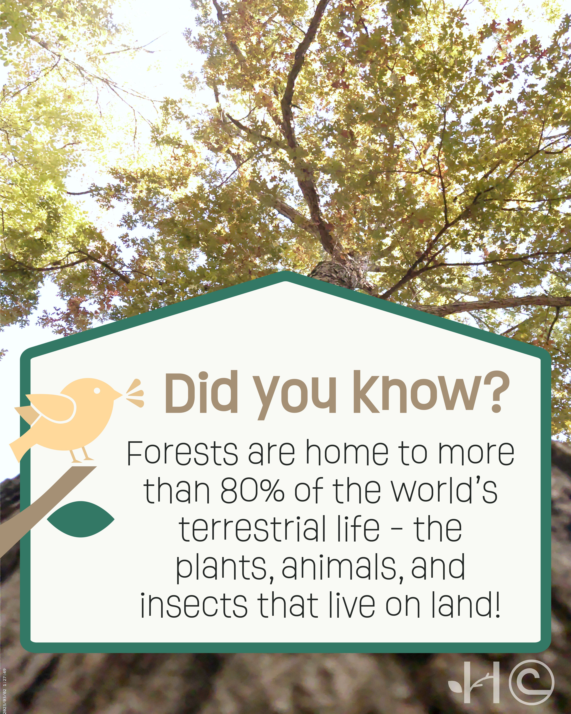 | FORESTS  Forests are home to more than 80% of the plants, animals, and insects that live on land! Conserving forests is about more than just trees – protecting forests also protects all the critters that call forests their home. Here in STATE/COUNTY, you’ll find ANIMALS living in our forests.  (i.e. Here in North Carolina, you’ll find gray squirrels, white-tailed deer, screech owls, gray tree frogs, and slimy salamanders living in our forests!)  #NACDStewardshipWeek #HomeIsWhereTheHabitatIs
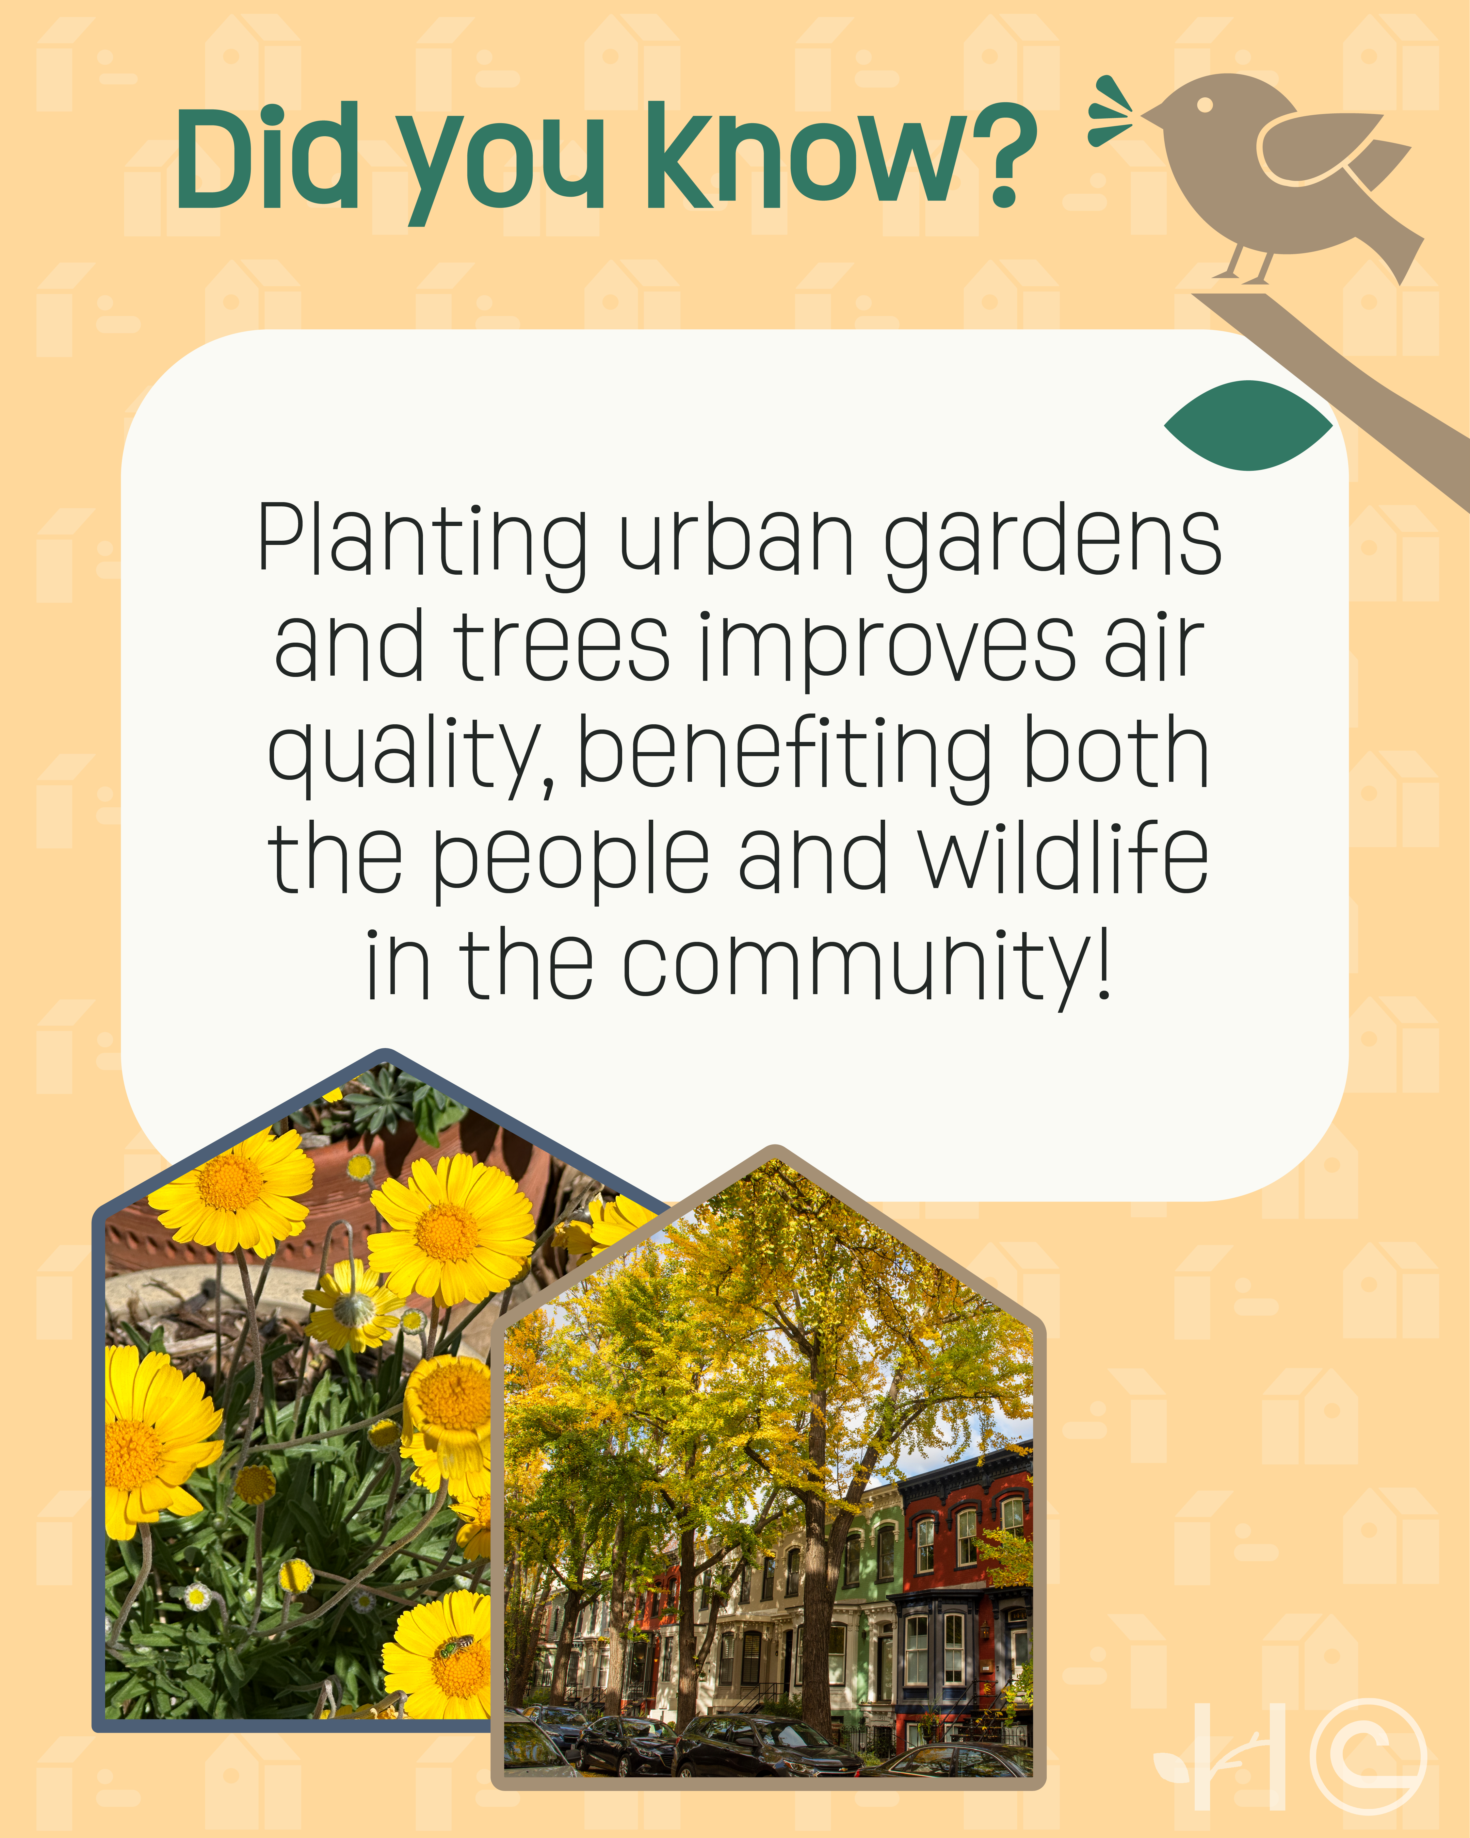 | URBAN  #Habitats are found everywhere. While you may not imagine a city when you think of habitats, gardens and other urban spaces are vital homes for plants and animals!  What are some animals you remember seeing from your last trip to an urban garden? 🌱🌻🌳🐝  #NACDStewardshipWeek #HomeIsWhereTheHabitatIs
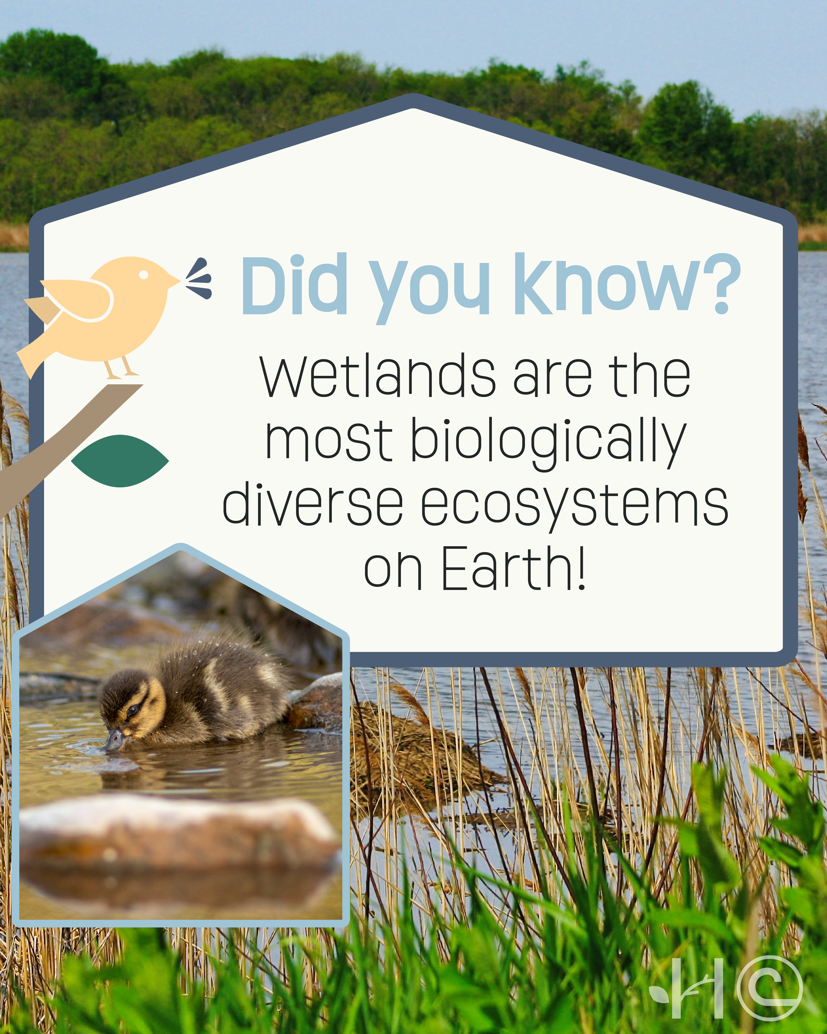 | WETLANDS  Wetlands are home to a wide array of species — including fish, reptiles, mammals, and everything in between. 🐟🦟🦎🦦🐢  Not only are these habitats vital to the various flora and fauna who call it home but also those living nearby. Wetlands can store floodwater, protecting surrounding communities from flooding.  #NACDStewardshipWeek #HomeIsWhereTheHabitatIs
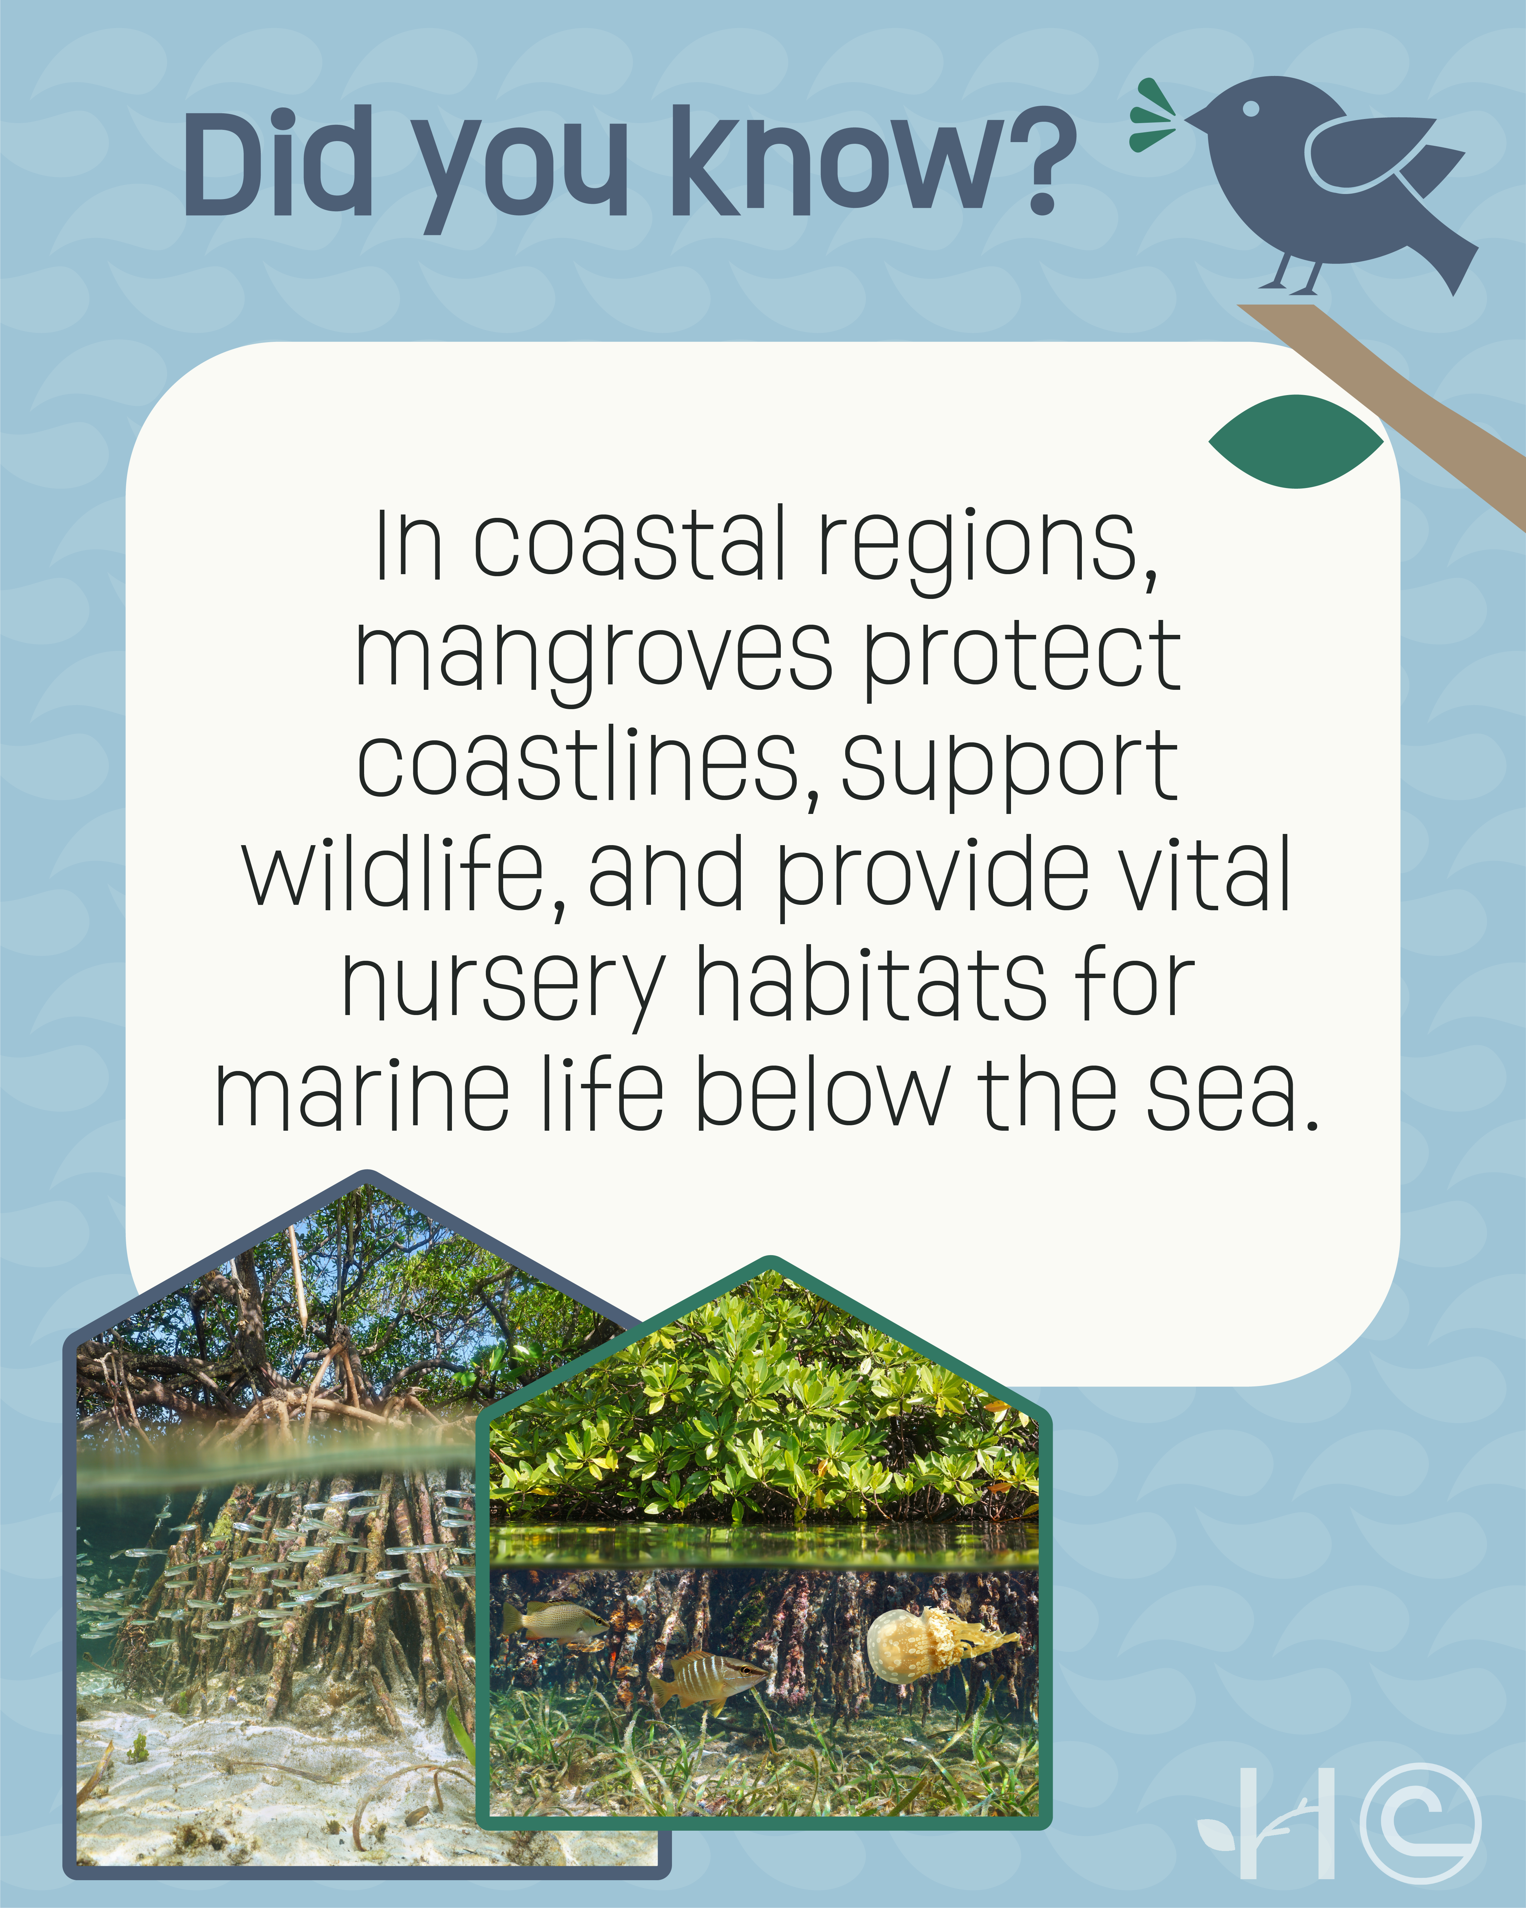 | COASTAL  Mangroves are tropical trees that thrive in salty, coastal waters. While most trees could not survive in these conditions, the roots of mangroves are able to provide nesting and nursery habitat for marine life. From tiny fish to massive crocodiles, mangrove forests protect an estimated 1,500 different species! 🐠🐊  #NACDStewardshipWeek #HomeIsWhereTheHabitatIs
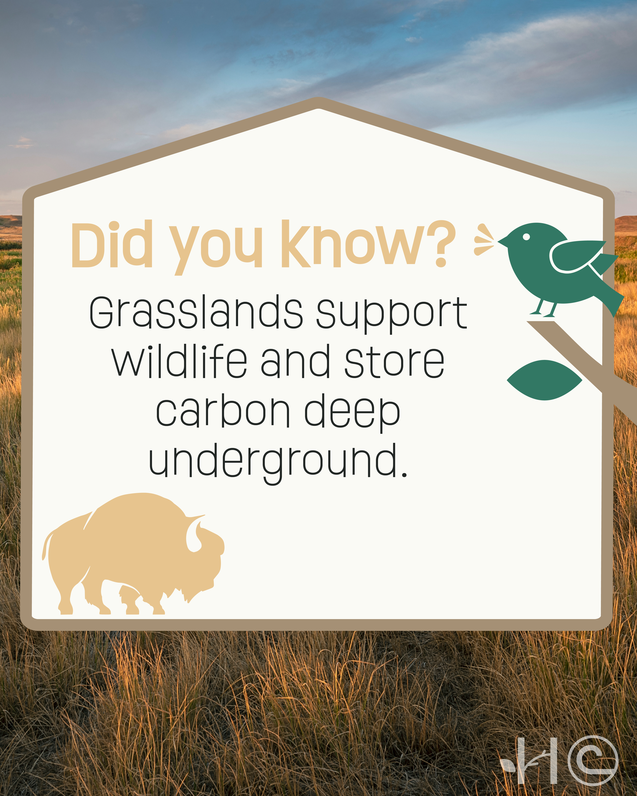 | GRASSLANDS  Grasslands, which support diverse wildlife from bison to birds, are America’s most endangered habitat. According to the @National Audubon Society, more than 360 million acres, or 60%, of #grasslands have been lost in the U.S., with another 125 million acres at high risk. It is crucial that we work to conserve these habitats!  #NACDStewardshipWeek #HomeIsWhereTheHabitatIs
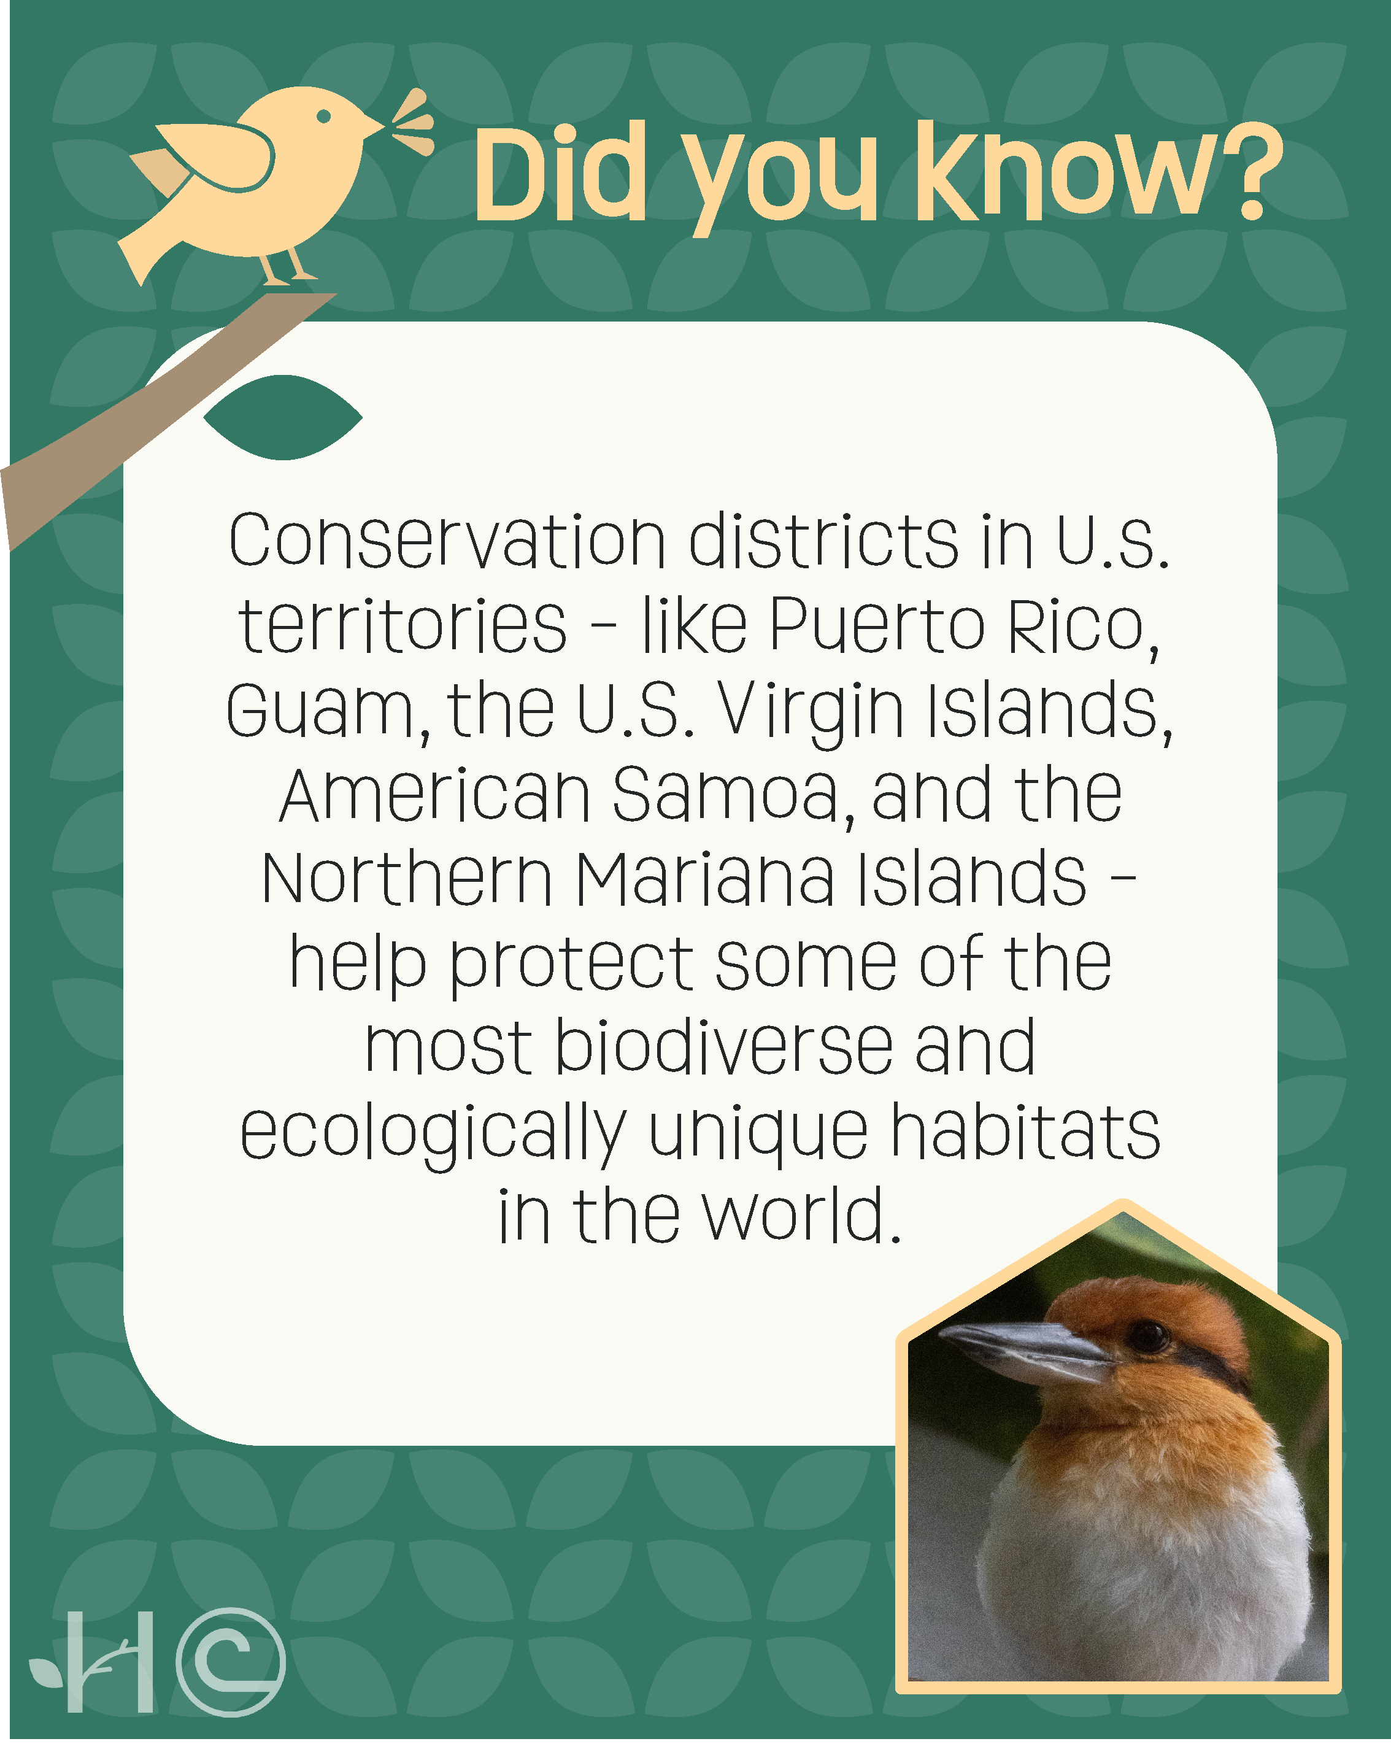 | DISTRICTS + TERRITORIES  The islands and coastal areas in some U.S. territories are home to rare tropical forests, coral reefs, and vital wetlands that support endangered species and provide essential ecosystem services.  #ConservationDistricts here work alongside local communities to restore habitats, prevent erosion, protect water resources, and promote sustainable agriculture. From planting native trees in American Samoa to protecting coral reefs in the Virgin Islands, these locally led efforts ensure that both people and wildlife can thrive for generations to come!  #NACDStewardshipWeek #HomeIsWhereTheHabitatIs
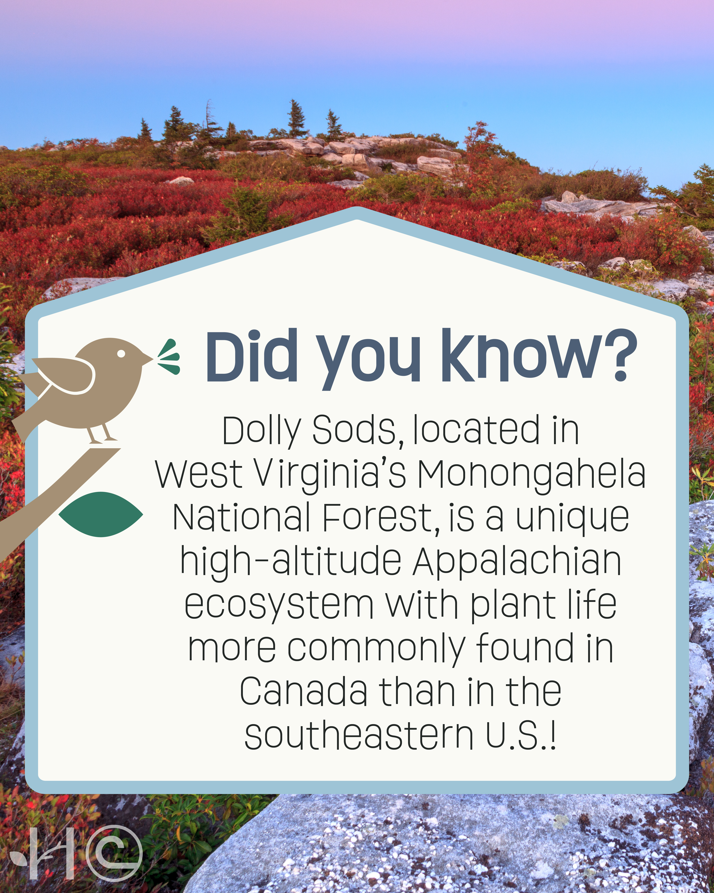  TEMPLATE | LOCAL / WEST VIRGINIA  Use the linked template to create a fun fact of your own! Just click “Use this template in a design” and you can change the colors, background photo, and text to create something specific for habitats in your area. We’ve included an example using the West Virginia Dolly Sods!

